Lab 9: The Moon, Revisited
Student’s Name
Institution
Date
Lab 9: The Moon, Revisited
Part I: Interpreting our Observations of the Moon
1
I observed eight lunar phases that include waxing crescent, new moon, first quarter, waxing gibbous, full moon, waning gibbous, last quarter, and waning crescent.
2
The distance was about 50 kilometers, with the moon not at the zenith but getting close at the earth's overhead.
3
We located the direction of the moon somewhere at the western horizon. The time was about 9 p.m. when such observation got made in the universe.
4
I could not cover the moon with the tip of my hand because it was near the earth with giant body size. The moon was the first quarter and was near the earth.
Lunar phase | Range of dates observed
New moon | 14 December
Waxing crescent | 22 December
First quarter | 1st December
Waxing gibbous | 27th December
Full moon | 30th December
Third quarter | 8th December
Waning crescent | 11th December
5
First Quarter
1st Dec

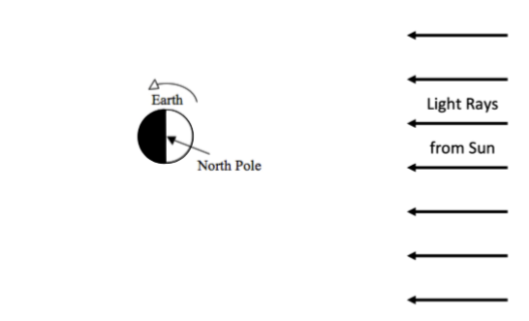
Third Quarter
8st Dec
Full moon 30th Dec
New Moon 14th Dec
6
I used the dates that the moons appear in the different months to ensure that the date's right estimate gets determined. 30 + 1 + 14 +8 = 53.
7
A maximum of 31 days is in one month; therefore, 53 – 31 leads to the creation of 22 days.
Part ii: The Clockwork Moon
1
Phase | Rise time | Highest in sky | Set time
New | 3 a.m. | 9 p.m. | 3 p.m.
First quarter | 3 a.m. | 9 p.m. | 3 a.m.
Full | 3 a.m. | 9 a.m. | 3 p.m.
Third quarter | 3 p.m. | 9 p.m. | 3 a.m.

2
Phase | Rise time | Highest in sky | Set time
Waxing crescent | 3 p.m. | 9 p.m. | 3 p.m.
Waxing gibbous | 3 a.m. | 9 p.m. | 3 a.m.
Waning gibbous | 3 a.m. | 9 a.m. | 3 p.m.
Waning crescent | 3 p.m. | 9 p.m. | 3 a.m.
3
The time makes sense because they are more or less in the same period of making observations. For instance, seeing the waxing crescent rise at 3 p.m. got done by many students.
4
The time would be after midnight, most likely at 3 a.m.
Part iii
1
The moon is tidally locked because of the change of its orbit.
2
24 hours and 50 minutes
3
The moon contains a dark side
4
Yes
5
Waning gibbous
6
Yes
7
The moon takes the time to complete one spin on its axis take long. The movement of the moon on its axis takes one year.

